**Turkey hotel staff 'sorry' after fake ISIS attack with commentary**

**A holiday firm has apologised after hotel staff in Turkey staged a mock terrorist attack for guests.**

One British holidaymaker said he was left "terrified" by the stunt at the Grand Yazici Mares hotel in Icmeler.

The supposed joke came just six weeks after so-called Islamic State gunman, Seifeddine Rezgui Yacoubi, killed 38 people in Tunisia.

Jet2holidays said the hotel's stunt, last Thursday, was never meant to cause "offence".

Electrician Jason Pythian, 43, from Manchester, said he was among dozens of British tourists by the pool when mock Arab terrorists, holding fake guns, dressed in Middle Eastern outfits and army gear appeared last week at the hotel in Turkey.

## More related stories

[[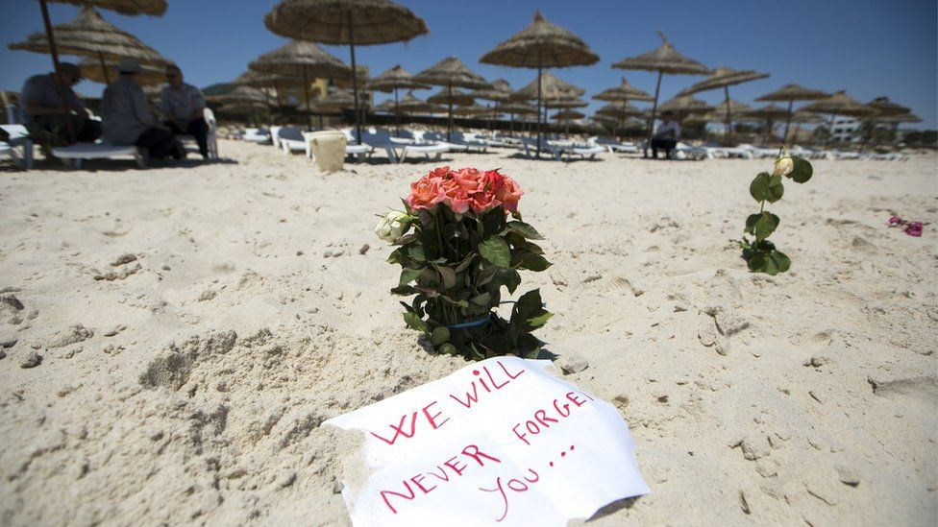](http://www.bbc.co.uk/newsbeat/article/33310386/four-acts-of-bravery-in-tunisia-attack)](http://www.bbc.co.uk/newsbeat/article/33310386/four-acts-of-bravery-in-tunisia-attack)

### [Four acts of bravery in Tunisia attack](http://www.bbc.co.uk/newsbeat/article/33310386/four-acts-of-bravery-in-tunisia-attack)

[[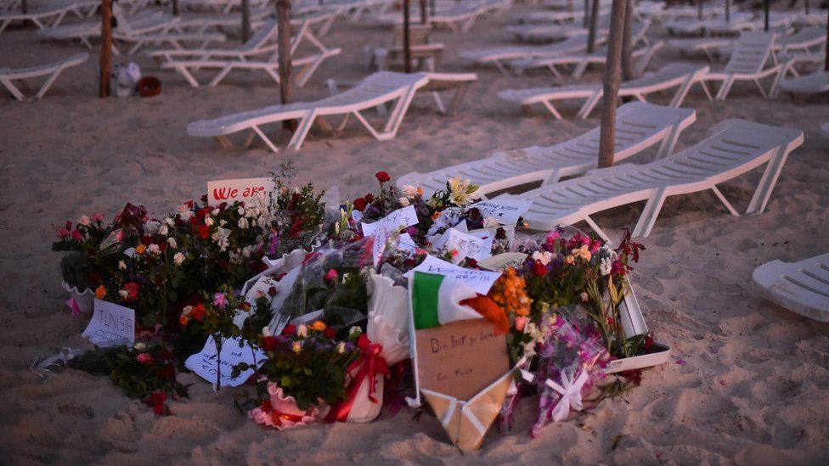](http://www.bbc.co.uk/newsbeat/article/33306126/tunisia-attack-what-we-know-so-far)](http://www.bbc.co.uk/newsbeat/article/33306126/tunisia-attack-what-we-know-so-far)

### [Tunisia attack: What we know so far](http://www.bbc.co.uk/newsbeat/article/33306126/tunisia-attack-what-we-know-so-far)

Mr Pythian told [The Sun](http://www.thesun.co.uk/sol/homepage/news/6586788/Hotel-staff-in-sick-mock-IS-attack-stunt.html) that only after they ran for their lives fearing another massacre did they realise it was a prank.

He told the newspaper: "We were so relieved - it was the hotel's idea of entertainment for the day.

"They thought it was funny to run around the pool dressed as terrorists.

"One ran up to me with a bucket with 'Fuel' written on the side.

"He threw it over me and got out a cigarette lighter. It was disgusting to try and make light of Tunisia in that way."

He was in a family party of six who'd paid tour operator Jet2holidays more than £5,000 for a 12-day all-inclusive stay to celebrate his father George's 70th birthday.

They flew to the Dalaman coast on 30 July.

Icmeler is less than 400 miles from the border with Syria, where much of the country is controlled by terror group Islamic State.

A spokeswoman for Jet2holidays said: "We are sorry to hear about the distress experienced by the Sutton family and on hearing this we immediately spoke to the hotel management.

"They have assured us it was never their intention to cause any offence or upset with their entertainment programme.

"This was a Hollywood-themed poolside show, which included the characters Rambo and Superman, and it is always well received by the hotel's residents.

"The hotel management now understands that some of the costumes may have caused offence and they will no longer use these in their shows."

However, an online comment by another British holidaymaker currently staying at the hotel played down the joke.

They told [Mail Online](http://www.dailymail.co.uk/news/article-3195906/Hotel-staff-Turkish-resort-packed-British-holidaymakers-stage-mock-ISIS-attack-fake-guns-cans-fuel-just-six-weeks-Tunisian-beach-massacre.html): "The Hollywood Theme pool entertainment could have been seen as insensitive but was in no way scary as the entertainers all had comedy make-up and a commentator was providing a running commentary.

"No-one appeared scared, no-one was running for their lives, it certainly needed to be taken in context."